Checker
1. Problem Statement
Validate student identifiers, names, marks, and course records stored in lists and tuples; detect duplicates, missing values, and inconsistent academic records.
2. Objectives
- Use basic iteration and conditional checks over a list of student records.
- Identify duplicate student IDs or invalid academic data.
3. Assumptions
- Records are stored as tuples: (roll_number, name, marks, attendance).
- Valid marks must be between $0$ and $100$.
4. Algorithm
- Start.
- Define a list of student record tuples.
- Keep track of seen roll numbers to detect duplicates.
- Loop through records, unpack them, and check if marks or attendance are out of valid bounds.
- Display inconsistency warnings.
- Stop.
5.Flowchart
[Start]
--> [Define student records tuple list]
--> [Loop through each record and unpack components]
--> [Check if Roll Number is already in seen_list?]
├── Yes --> [Flag DUPLICATE ERROR]
└── No --> [Add Roll Number to seen_list]
--> [Check if Marks < 0 or Marks > 100?]
├── Yes --> [Flag INVALID MARKS ERROR]
└── No --> [Mark record as OK]
--> [End of Loop]
--> [Print Final Audit Summary and Error Count] --> [Stop]
6. Pseudocode
START
records = [
("R101", "Alice", 85, 90),
("R102", "Bob", 105, 80), // Invalid marks > 100
("R101", "Alice", 85, 90) // Duplicate roll number
]

seen_ids = []
FOR each rec IN records DO
UNPACK rec INTO r_id, name, marks, att
IF r_id IN seen_ids THEN
PRINT "Duplicate ID detected:", r_id
ELSE
ADD r_id TO seen_ids
ENDIF

IF marks < 0 OR marks > 100 THEN
PRINT "Invalid marks for student:", name
ENDIF
ENDFOR
STOP
7. Python Source Code

print("=== Student Record Consistency Checker ===")

student_records = [
("CSE01", "Rahul", 88, 85),
("CSE02", "Sneha", 92, 90),
("CSE03", "Kiran", 105, 75), # Invalid marks (> 100)
("CSE01", "Rahul", 88, 85), # Duplicate Roll Number
("CSE04", "Pooja", 45, 50) # Low marks/attendance
]

print("\nRunning Record Consistency Audit...\n")

seen_roll_numbers = []
error_count = 0

for record in student_records:
roll_no, name, marks, attendance = record

if roll_no in seen_roll_numbers:
print("ERROR: Duplicate record found for Roll Number:", roll_no, "(Student:", name, ")")
error_count = error_count + 1
else:
seen_roll_numbers.append(roll_no)

# Check for invalid marks
if marks < 0 or marks > 100:
print("ERROR: Invalid marks (", marks, ") for student", name, "[Roll No:", roll_no, "]")
error_count = error_count + 1
else:
print("OK: Record valid for", name, "(Marks:", marks, "| Attendance:", attendance, "%)")

print("\n--- Audit Summary ---")
print("Total Records Checked :", len(student_records))
print("Total Inconsistencies :", error_count)
8. Test Cases & Output Log
- Test Case: 5 records containing a duplicate and out-of-bound marks.
- Log:
=== Student Record Consistency Checker ===
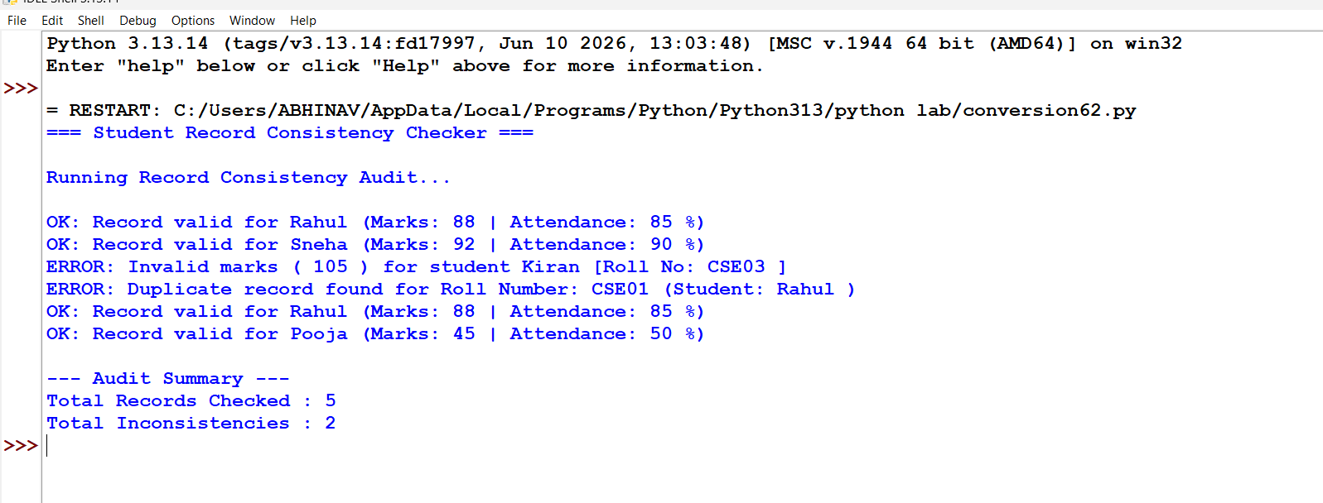
Conclusion: Successfully validated multi-attribute student data structures containing lists and tuples to detect data inconsistencies, duplicate identifiers, and out-of-bound academic values.

